Evaluation of window lighting considering the circadian effect

Yingqiao Liu ¹, Tongsheng Mou ²

¹ Department of Optical Engineering,Zhejiang University, Hangzhou, China,
² Smart and health lighting research center, Zhejiang, China,
²mou@sensingm.com

Abstract
Natural light stimulates effectively the human visual system, metabolic system and circadian rhythm. Status of circadian rhythm is now considered to be an important representation of health, because circadian disruption may cause dysfunctions such as insomnia, cardiovascular disorder and emotional disturbance like depression. Natural light is by far the most important entraining cue of circadian rhythm. However, many offices and rooms were designed without windows in modern building due to restriction of structure, which disenable indoor workers to have access to natural light. Therefore, an artificial window on the wall of a window-less room, which simulates the natural day light penetrating a window, is possible to solve this problem. We present here a simulating window consists of four channels of LED based on consideration of visual chromaticity performance and circadian effect. Experimental results showed that it could simulate the light environment outdoor as a day progresses.

Keywords: Natural light, Circadian rhythm, Window lighting, Artificial window, LED

Background
Have you ever imagined how it feel if the natural light not reach to us anymore and have to live indoors in the rest of our lives? It sounds awful, however, people living in modern cities seems to already acclimatize themselves to environments without sunshine for most of them are indoor workers. However, with the development of medical researches, several diseases result from insufficient exposure to light were observed.
Natural light illuminates the indoor environments and meanwhile as a heat provider in winter months. Moreover, it stimulates effectively human visual system, metabolic system and more importantly, the circadian rhythm. Circadian rhythm is defined as biological cycles of physiological parameters in a period of about 24 hours including body temperature, hormonal levels, sleep pattern, cognitive performance, etc. Normalization of circadian rhythm is crucial to human health, because it regulates a series of genes involves in occurrence and development of diseases including cancer. Thus, disorder of circadian rhythm is adverse and even lethal to human. In mammals including human, suprachiasmatic nucleus (SCN) in the hypothalamus of brain act as circadian pacemaker. It was observed that when SCN were removed from experimental animals or damaged, they lost their normal biological rhythms, while transplanting the SCN back into their brains, the normal rhythms were restored.
Because the intrinsic period of the SCN oscillator is not exactly 24 h, it drifts out of phase with the solar day unless synchronized or ‘entrained” by sensory inputs[1]. Natural light is the most effective zeitgeber for circadian rhythm entrainment, it modulates SCN activities through a pathway from retina to hypothalamus called retinohypothalamic tract (RHT). Intrinsically photoreceptive retinal ganglion cells( ipRGCs) , a novel photoreceptor in the eye discovered by David Berson et al. in 2002[2], are the most important circadian rhythm participants.
Melatonin, a kind of hormone secreted from pineal body in the brain act as a marker of circadian rhythm phase shift, because its secretion follows a restrict pattern of circadian rhythm variation[3,4]. Blue light with a peak value at about 460nm distinctly inhibit the pineal melatonin release.
Ten years ago, incandescent lights and fluorescent lights were generally used in domestic lighting. Lamps with low colour temperature are relatively suitable for night illumination for their less short-wavelength blue light content, while daylight fluorescent lamps with high colour temperature(6500K) are considered to be more suitable for office lighting in daytime. However, these lamps keep a constancy in the process of illuminating , which actually desynchronize the physiological needs of circadian rhythm that formed in human evolution within the natural 24-hour cycle.
For the past few years, LEDs got fast development for characteristic of not only high luminous efficiency and long life , but also wide range of spectral and intensity variability, which possibly achieve simulation of spectra and periodical variation of daylight when combined with an intelligent electronic dimming system. Moreover, visual demand and circadian rhythm requirements could be achieved simultaneously in office, and thus provide a simulated natural light environments for indoor workers who chronically spend most of their time indoors.

2 Windows lighting simulation
2.1 Consideration of window scene
When considering the scene in need, people’s background like culture and customs should be included, meanwhile it should also make people feel open and pleasure. In the simulating window, we chose the scene of West-lake, the most beautiful place in China, according to a consideration that “mountains and water constitute a beautiful scenery always”. Therefore,we took a photograph depicts the scene of Wes-lake towards the east on a mountain with medium altitude in a sunny day within a midsummer.

2.2 Materials
Four channels of LED(Figure 1) used in the simulating window are listed as follow with chromaticity coordinates presented in x and y:
Warm white LED(100 W), x=0,2566,y=0,3166
Cool white LED(100 W), x=0,3782,y=0,4151
Blue LED(80 W) , x=0,1392,y=0,0751
Red LED(60 W), x=0,6709,y=0,3120
A photograph including blue sky, clouds, trees, buildings, rocks, an ancient pagoda and the famous West-lake was taken from Baochu mountain, Hangzhou in a sunny day, and then printed in a plastic film with colour spray. A luminometer and CCD spectrometer were applied for the measurement.
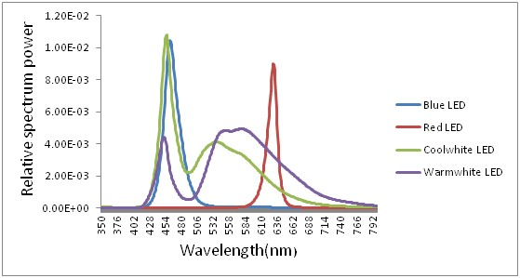
Figure 1 – Relative spectral power of the four wavelengths used in the window
2.3 Construction
A simulating window, in a size of 3.0 m ×1.5 m, consists basically of four channels of LEDs with integrated heat sink plate and a photograph(Figure 2) fixed in a window frame(the simplied construction of the simulating window is shown in Figure 3). The LED bars locate in a distance of 6 cm from the scene picture. The four LEDs with different colour were assembled in order to simulate the lighting conditions of natural daylight (morning, midday, afternoon and dusk) during midsummer months. They are dynamically controlled by a four-channel DMX512 and drived by PWM via a computer, and also dimmable with luminance dividing into 255 levels.
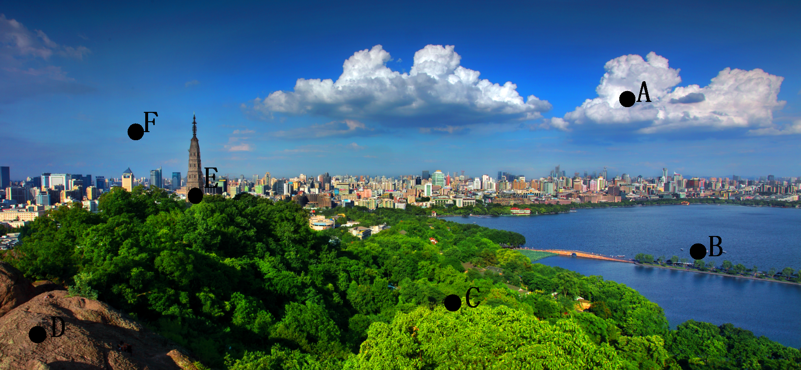
Figure 2 – The scene of West-lake in which seven characteristic points are labelled (see below in detail).

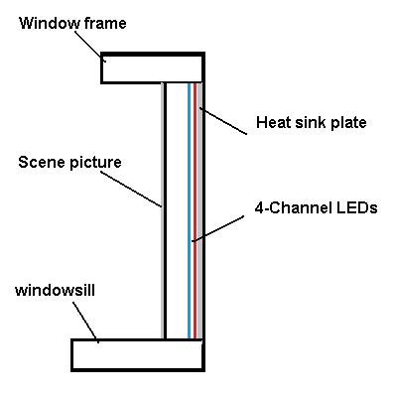
Figure 3- Simplified diagrammatic presentation of the construction of simulating window.
To evaluate the consistency of lighting conditions of the simulating window with the corresponding natural environments, seven points on the photograph(Figure 2) was selected and their chromaticity, luminance and spectroscopic data ware recorded with four LEDs turned on individually or simultaneously. Average data of the chromaticity coordinate were obtained according to area of each objects. Circadian action function a_{cv} is defined by GALL[5] as the ratio of the effects of circadian rhythm to the photopic quantities , which we refer to as C/P value here with a spectral range from 380 nm to 780 nm. C/P value with a spectral range from 380 nm to 780 nm was calculated as follow:

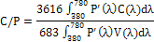 (1)

Where
P’ (λ) is the relative spectral power distribution
C (λ) is the circadian action function
V (λ) is the photopic luminous efficiency function

3. Evaluation
To evaluate the effects of illumination and scene of the simulating window, seven characteristic points including the sky, water surface and trees which take over greater areas were selected, and visually appealing view spots like clouds,ancient pagoda, buildings and rocks were also included. Then effects of colour simulating of the characteristic points were evaluated, along with the light and colour parameters of the whole scene on the photograph as well as circadian rhythm-regulating parameters of human body(Figure 4).

The measurements of spectral irradiance and chromaticity coordinate of the whole

simulating window are performed at a distance of three meters front of the window. Thus we got the simulating gamut of chromaticity coordinates of the simulating window in the room.The range of controllable chromaticity is consist of cool white, warm white ,red and blue.
Spectral and chromaticity data of the natural light environments where we took the photo were recorded by a luminometer and spectrometer from 8:00 am to 5:00 pm with a interval of 30mins at the same day the picture was took.
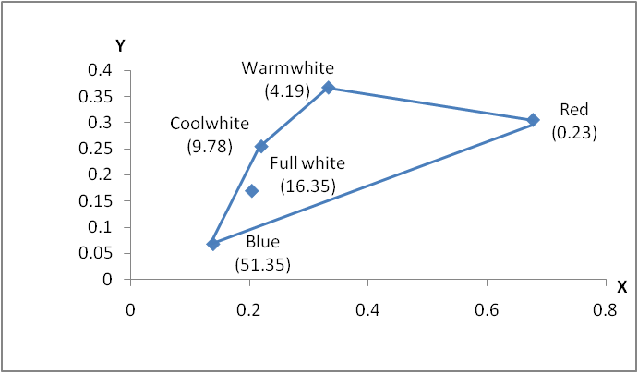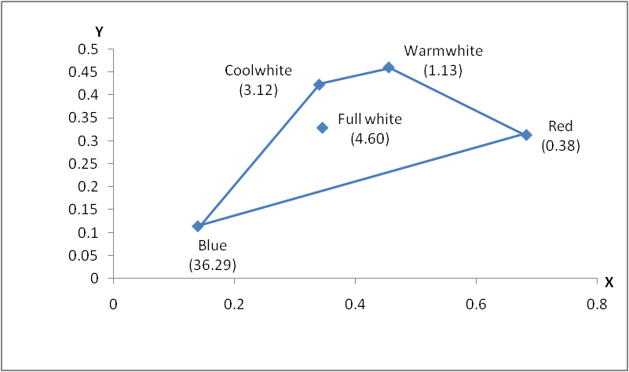
（A）Sky (B) Ancient pagoda
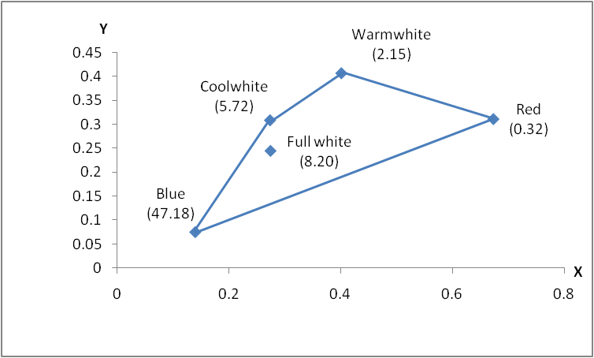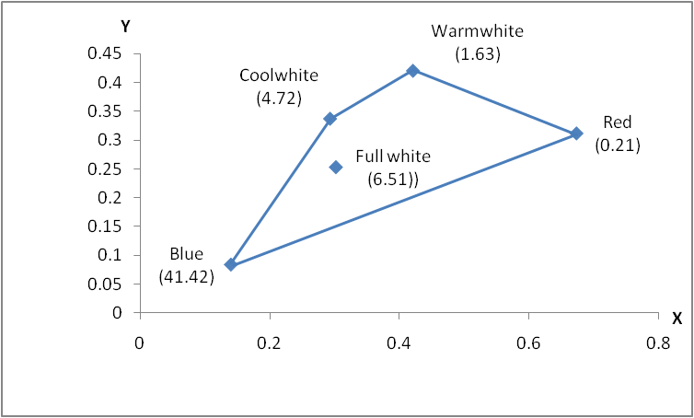
（C）Clouds (D) Buildings
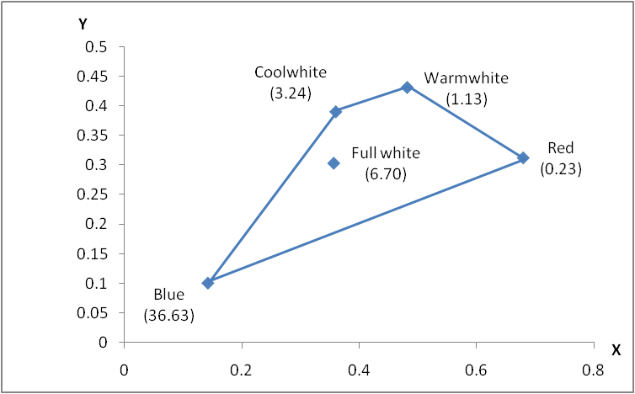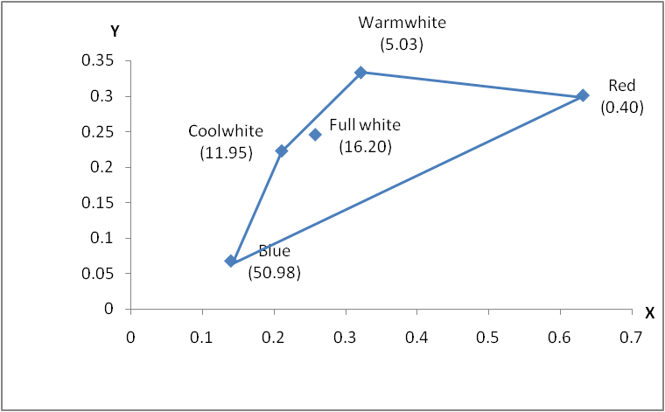
(E) Rocks (F) West-lake
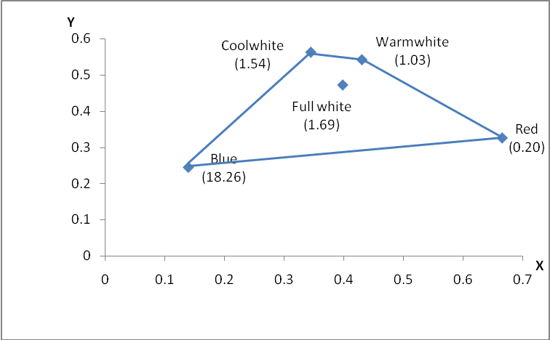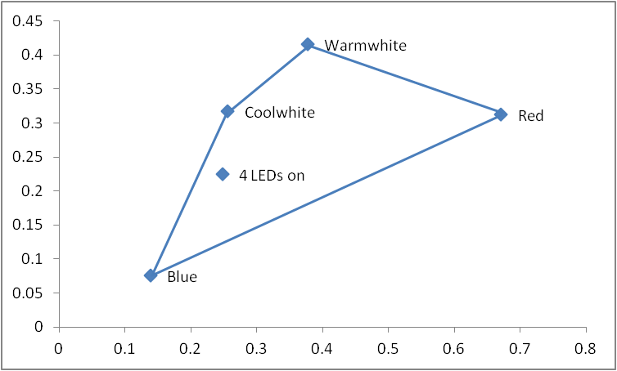
(G) Trees (H) Average

Figure 4 –(A)-(G) represent the chromaticity coordinates and C/P values(round brackets) of the seven characteristic points while (H) the average.

We chose four scenes in time phases of 9:00am, 11:00, 13:00pm and 15:00pm for evaluation of the consistency of the windows lighting and actual scene regarding C/P values, results are represented in Figure 5,in which trees are the subjects for evaluation. As seen from Figure 5, the difference in C/P values is not obvious which indicates the window is able to have the similar effects on human circadian rhythm. Other diversities of colour temperature and luminance varation illustrated similar results(data not shown).
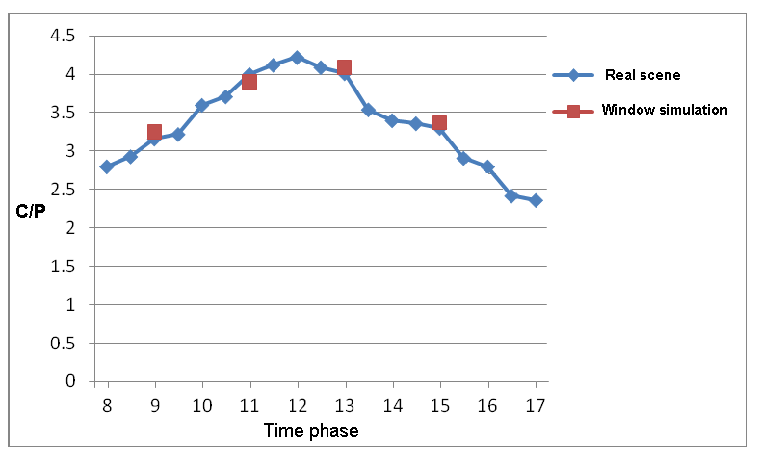

Figure 5 The C/P values of trees in the LED simulating windows(orange) and corresponding outside scene(blue)

4. Conclusion
In morden buildings, the absence of windows in certain occasions makes accessing to natural sunlight and outside natural scenes impossible. This paper made use of dynamic back-lighting with four channels of LED and a landscape of West-lake, which are dynamically controlled by DMX512, thus the scenes of West-lake in different time phases during a day could be simulated. Therefore, it simulates not only the variations of colour temperatures and light intensity during 24 hours, but also makes observers pleasure and brings stronger stimulations of circadian rhythms to them by seeing the window’s scene.
The scene on the photograph was chosen in consideration of people’s preference on natural scenes like mountain, sky, lake and trees, which in combination give visual satisfaction and a feeling of joy. According to Chinese tradition, general attention is paid to mountains and waters when estimating a scene. Thereby, we took a photo at a location on the Baochu mountain which enable us to see the whole West-lake facing the East . Characteristic points were taken from a large field of view (such as trees, lake surface, the sky, etc.)and visually appealing view spots (such as ancient pagoda\clouds, etc.).
Different light intensity, chromaticity coordinates and C/P values could be simulated through dynamically controlled regulation. In the example presented in this paper, the C/P values of trees are quite close to the corresponding status in nature. It simulates the natural day light penetrating a window as a day progresses through alteration of C/P values. This four-channel LEDs is capable of simulating the lighting conditions of natural environments in wide range of time phase from morning to dusk. The experimental results showed that the simulative sight was significantly close to natural fluctuation of ambient light. This window is taking into full account several factors including the high luminous efficiency, visual comfort, non-visual stimulates (morning to midday) and heat dissipation.
This novel artificial window provides a new alternative for modern architectural lighting. It satisfy circadian rhythm and visual effects simultaneously but more attention was pay to the former.

Reference:
1. Berson, DM.2003. Strange vision: ganglion cells as circadian photoreceptors. TRENDS in Neurosciences., 26,314-320.
2.Berson, DM. Dunn, FA. Takao, M. 2002. Phototransduction by retinal ganglion cells that set the circadian clock. Science., 295,1070-1073.
3. Claustrat .B, Brun. J, Chazot. G., 2005. The basic physiology and pathophysiology of melatonin. Sleep Med Rev., 9:11–24.
4.Raikhlin, NT. Kvetnoy, IM. Tolkachev, VN. 1975. Melatonin may be synthesised in enterochromaffin cells. Nature., 255:344–345.
5.GALL,D. LAPUENTE, V. Beleuchtungsrelevante Aspekte bei der Auswahl eines förderlichen Lampenspektrums. Licht., 54, 860 – 871.

